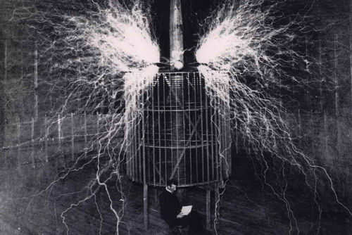

**It may be theirs at present, but the future is mine.**

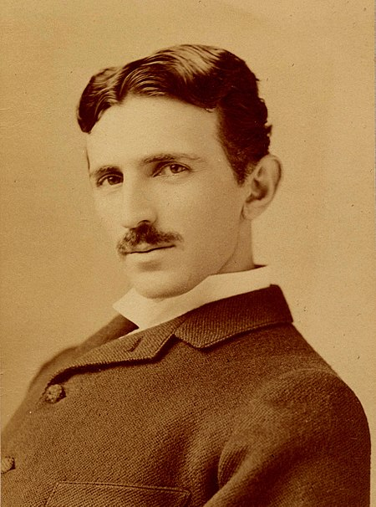

Nikola Tesla

**(Electrician, Inventor, July 10, 1856 – Jan 7, 1943)**

**Intuition transcends knowledge.**